Sanborn Regional Middle School
, November 25, 2019 ~ Today is an “E” Day

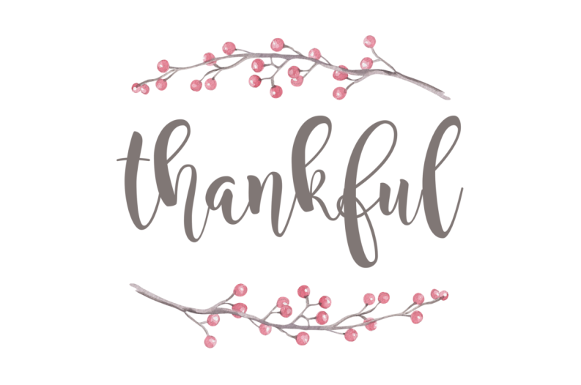

- AFTER-SCHOOL ACTIVITIES

DATE | November 25  Monday | November 26  Tuesday | November 27  Wednesday | November 28  Thursday | November 29  Friday
Clubs and Activities | Play Rehearsal  SRHS Auditorium  5:00-7:30  Student Council  2:30-3:30 | Play Rehearsal  CANCELED | No School  Thanksgiving Break
Basketball | GIRLS A  3:00-4:30 Swasey  Bus 203  GIRLS B  2:30-4:00 SRMS  BOYS A  4:30-6:00 Swasey  BOYS B  5:00-6:30 SRMS | GIRLS A  4:30-6:00 Swasey  GIRLS B  2:30-4:00 SRMS  BOYS A  3:00-4:30 Swasey  Bus 203  BOYS B  5:00-6:30 SRMS

- DATES TO KEEP IN MIND

- Friday, December 6 – School Play, A Christmas Carol – 7:00 PM, SRHS Auditorium
- Saturday, December 7 – School Play, A Christmas Carol – 2:00 PM Matinee, SRHS Auditorium
- Friday, December 13 – School Dance, All grades, SRMS Gym, 7:00 PM – 9:00 PM

